

MULTIVARIATE DATA SCIENCE ANALYSIS FOR TOURISM AND HOSPITALITY USING PYTHON
Customer Segmentation and Personalised Tourism Experiences Using Clustering Algorithms and Behavioural Analytics
Individual Project Assignment
Module: Programming for Data Science
Module Code: EAM02DS
Programme: MSc Data Science & AI
Student Name: Drashti Jigneshkumar Patel
Student ID: 10504966
Module Leader: Dr. Mostafa Kamil Al-Harbawi
Semester: July 2026
Submission Date: 1 September 2026

TABLE OF CONTENTS
Serial Number | Topic
1 | Abstract
2 | Introduction  Background and context  Customer segmentation in tourism  Problem statement and project motivation  Project’s aim  Objectives  Research Questions
3 | Literature Review
4 | Data science project Lifestyle  Data Acquisition  Data Preprocessing  Exploratory Data Analysis  Modelling Technique  Interpret
5 | Conclusion
6 | References

Abstract
The tourism and aviation industries increasingly rely on data-driven strategies to understand the preferences of diverse travellers and improve customer experiences. This study aims to identify different traveller segments based on their individual preferences. Treating travellers as a single customer group may fail to provide a clear understanding of their preferences and interests across different tourism activities.
The study uses the UCI Travel Review Ratings dataset, which contains individual user ratings across 24 tourism-related categories. Principal Component Analysis (PCA) was used to examine the underlying structure of the multivariate preference data, while multiple cluster configurations were evaluated using clustering validation measures. Data preparation and exploratory analysis were also conducted to ensure that the dataset was suitable for analysis.
Following the analysis, the users were classified into two distinct segments: Food, Shopping & Entertainment Tourists and Nature & Scenic Tourists. The two segments demonstrated different preference patterns across tourism categories, highlighting the diverse nature of traveller interests. From an aviation industry perspective, these findings could help organisations better understand customer travel interests and support more targeted destination recommendations, travel services and customer engagement strategies. Overall, the study demonstrates how tourism preference data can be used to identify meaningful customer groups.
Keywords: Tourism analytics, traveller segmentation, K-Means clustering, Principal Component Analysis, aviation industry
- Introduction
  - Background and Context
The travel and hospitality sector deals with varied customer expectations, interests and travel motives. For instance, the Aviation sector could potentially use the users’ preferences to tailor destination recommendations to different tourist’s groups. From a Data Science perspective, the report views tourist ratings as multivariate data across multiple categories and uses them for grouping into clusters. An explorer may get several experiences while visiting a place which could be in terms of living, shopping, food, scenic views. For good customer engagement, it’s mandatory for the organisation to consider these increasing variations and diverse expectations.
The increasing use of social media and internet surfing for destinations also transforms the way information is generated because these days human rely more on ratings rather than visiting the place physically. Online ratings about a place also provide a large quantity of customer-generated information that showcases how users evaluate different aspects of tourism. While these ratings are just classified as numerical values rather than isolated measures, they can provide a bigger picture of customers’ preferences which in turn also helps the travel sector understand the underlying patterns of visitors. This also has a broader opportunity for data science where the complex information can be used to create manageable customer profiles by grouping the similarities into clusters.
The report’s scope is towards personalised experiences and customer segmentation. The brief identifies segments using clustering algorithms and analytics based on behaviour. The dataset from UCI about Travel Review Ratings, where the users rated across 24 different categories contains a mix of different interests. Rather than going through each category individually, this report combines rating patterns and investigates the interests of travellers.
The selected dataset is highly suitable because it has 24 categories which directly create a multivariate data analysis rather than an individual rating analysis.
  - Customer segmentation In Tourism
Customer segmentation refers to grouping various types customer populations on the basis of similar traits, behaviour, interests and preferences. Segmenting in the tourism industry provides a clear picture of who has which interests which can easily be distinguished from the wider range of population. Such profiles make it easier for the organization to classify and provide better recommendations.
The connection of segments becomes particularly visible when passengers display different priorities. For example, some groups of people may give more value to food, entertainment and shopping while some may demonstrate an interest in nature views and scenic attractions. Grouping by only having an average of each group is not limited to have a clear picture while multivariate perspective is therefore used due to relationships between several variables can be considered simultaneously.
In this report, segments show a data-driven pattern discovery problem. The dataset didn’t provide a clear grouping of customers based on their preferences, on which they rated across 24 different categories. The distinction is not just about justifying which group rated the highest and which rated the least, but also its main aim was to understand customers’ preferences and then creating clusters in order to understand the underlying user patterns.

  - Problem Statement and Project Motivation
This paper seeks to tackle the problem that although the dataset contains user ratings of 24 tourism categories, it does not explicitly provide traveller segments based on their preferences. Thus the differing interests of users are not immediately apparent from the dataset. Some users may prefer shopping and entertainment related activities while others may have stronger preference for scenic and nature based attractions. These differences can be identified by analysing the rating patterns across the categories and grouping users with similar preferences.
The reason for choosing this topic is that the importance of customer-oriented decision-making is growing in tourism and aviation. Treating all travellers as a homogeneous mass ignores the important differences in what customers value. Segmenting users with similar preferences enables clearer customer profiles and can aid more targeted services, marketing and recommendations. From a data-science perspective, the study applies multivariate analysis to transform complex rating patterns into interpretable customer segments.
The resultant segments may also be of relevance to the aviation industry especially in understanding destination related passenger preferences. For example, travellers who prefer retail, gastronomy and entertainment may respond differently to destination information than travellers with a higher interest in scenic and ecological experiences. Such profiles could thereby form the basis for customized recommendations for destinations and for targeted marketing content. However, because the dataset represents general tourism preferences rather than airline-specific passenger behaviour, these applications should be considered potential implications rather than direct predictions of airline performance.

  - Project’s aim
The primary objective of this report is to evaluate the utility of multivariate tourism-rating data in identifying and interpreting distinct traveller segments based on consumer preferences. Additionally, this study explores how these derived profiles can be leveraged to enhance personalized customer experiences within both the tourism and aviation sectors.

  - Objectives
To achieve the following aim, the report follows these objectives:
- Prepare and clean the UCI tourism rating dataset to prepare it for analysis.
- View the pattern across ratings provided by the users.
- Using appropriate validation method, evaluating the segment structure and access the quality of the group.
- Apply dimensionality reduction to uncover the underlying patterns in multivariate data and validate the identified traveller segments.
- To profile and compare the identified traveller segments based on their tourism preferences and consider their potential applications for personalised travel experiences.

  - Research Questions
The following research questions are laid upon objectives:
- What distinct tourism preference segments can be identified from user ratings across the 24 tourism categories?
- Which tourism categories contribute most strongly to the underlying patterns identified through Principal Component Analysis (PCA)?
- How effectively can K-Means clustering separate users into tourism preference segments, and how does PCA affect the clustering solution?
- How can the identified traveller segments support targeted marketing, personalised recommendations and customer-focused decision-making in the tourism and hospitality sector?

- Literature Review
Users have different interests, motivations and preferences, thus the tourism patterns are heterogeneous. Therefore, recent research has increasingly regarded tourist segmentation as a data-driven problem, rather than simply assuming broad categories can sufficiently describe tourist behaviour. Pooja, Upadhyaya and Mohanty (2025) identified four preference-based profiles among 980 Indian domestic travellers and demonstrated the value of recognising differences within broad traveller groups. Their strength lies in their ability to identify variation within groups and to translate the profiles that emerge into practical implications for tourism marketers. In contrast, Rishi and Chatterjee (2023) studied travel motivations and used K-Means clustering for segmenting Indian domestic tourists. Both the studies recognize heterogeneity in Indian traveller. Pooja et al. took into account the preference-based profiles, while Rishi and Chatterjee deal with travel motivation. This comparison suggests that the type of variables used to characterize the tourists may be of major importance in the resulting segments. In the present study, the segments are directly based on 24 tourism-rating categories, so that the preference structure arises from the data instead of being defined by predetermined profile factors.
Although K-Means has been used in a number of tourism-segmentation scenarios, the studies also show variations in research environment and scale. While Carvache-Franco et al. (2023) employed clustering to identify three urban-tourism categories across four Latin American cities, Rishi and Chatterjee (2023) applied K-Means to 456 Indian visitors using motivation-focused survey measures. Although the unit of analysis and tourist setting are different, both studies show how beneficial K-Means is for identifying heterogeneous tourism groups. While Carvache-Franco et al. investigate urban tourism demand across particular places, Rishi and Chatterjee study individual travellers and their motivations. Instead of using a limited survey sample or an urban dataset relevant to a destination, the current study uses 5,455 individuals and 24 tourism-rating categories. This comparison shows that the size, structure, and purpose of the dataset all affect how useful K-Means is. Therefore, we believe that applying previously developed tourist classifications directly to the current dataset is unsuitable. Rather, the segments of the current study are derived from the observed rating patterns.
Additionally, the literature shows that when tourism datasets have a large number of variables, dimensionality reduction can be used with clustering. Smith, Pinke-Sziva, and Berezvai (2023) investigated travellers' preferences for tourism activities in Budapest using a two-stage method that involved PCA and Hierarchical Cluster Analysis. Wang et al. (2021) likewise employed PCA and clustering, but they analysed 146 Baidu search terms relevant to tourism using Modified Affinity Propagation. Both research employ PCA to reduce complicated tourism data, but their following grouping techniques and evidence sources are very different. While Wang & al. study online search behaviour, Smith et al. analyse tourist activity choices. In contrast, the current study employs K-Means following dimensionality reduction and user-level tourism ratings. This suggests that PCA does not determine the clustering method itself, but rather acts as a dimensionality-reduction tool. As a result, we approach clustering and PCA as two distinct methodological choices in the analysis.
Because their PCA–Modified Affinity Propagation framework beat K-Means, linkage clustering, and standard Affinity Propagation based on the Silhouette coefficient and Calinski–Harabasz index, Wang et al. (2021) present a particularly significant methodological challenge to K-Means. In contrast, works like Rishi and Chatterjee (2023) effectively obtained interpretable tourist segments using K-Means. The discrepancy implies that algorithm selection does not always determine clustering performance; rather, it depends on the dataset. While the current analysis captures user ratings across tourist categories, Wang et al.'s search-keyword dataset measures potential destination interest. As a result, their conclusion cannot be immediately applied to the current dataset, but it does offer a compelling argument for conducting an empirical evaluation of K-Means rather than presuming that it is the optimal approach. The methodical cluster-number selection and silhouette-based evaluation used in this work reflect this.
While Carvache-Franco et al. (2023) looked at urban-tourism segments across Latin American cities, Hernández, Bulchand-Gidumal, and Suárez-Vega (2021) offer another opposing application of K-Means by segmenting tourist areas using accommodation-price determinants. whereas both studies employ clustering to aid in tourist management, the current research acts at the individual-user level, whereas their findings operate at the destination level. While user-level segmentation is more directly related to consumer targeting and tailored recommendations, destination-level segmentation can help with tourism-area management and spatial planning. The goal of this study, which is to uncover traveller preference trends from tourism ratings, is more closely linked with the user-level method.
The significance of methodological evaluation is further supported by recent studies. Schrader et al. (2025) evaluated K-Means with Agglomerative Clustering, DBSCAN and HDBSCAN for visitor profiling, revealing that different algorithms can generate varied clustering conclusions. In a similar vein, Airlangga (2025) used numerous internal validation criteria to assess multiple clustering techniques following standardization and PCA. Together, these investigations strengthen the claim expressed by Wang et al. (2021): clustering quality should be measured empirically rather than inferred from the popularity of an algorithm. Nevertheless, these research' more comprehensive algorithm comparisons are outside the purview of this project. Therefore, we used the Elbow approach and Silhouette Score to evaluate the adequacy of the final cluster design, and K-Means as a workable and comprehensible approach for the given dataset. Compared to choosing a cluster number without validation, this offers a more convincing foundation for segmentation.
Synthesis
Although the examined research generally concur that tourist populations are diverse, there are significant differences in the methods used to quantify and characterize this diversity. While Smith et al. (2023) and Wang et al. (2021) show the importance of simplifying complicated tourism data prior to clustering, Pooja et al. (2025) and Rishi and Chatterjee (2023) show variance in individual traveller choices and motives. While Schrader et al. (2025) and Airlangga (2025) emphasize the significance of contrasting and assessing alternative clustering methodologies, Hernández et al. (2021) and Carvache-Franco et al. (2023) demonstrate that clustering can also enhance destination-level tourism management.
While addressing a distinct analytical setting, our study expands upon these conclusions. It examines individual user ratings across 24 tourism categories instead of utilizing demographic data, travel reasons, lodging features, search behavior, or destination-level indications. To extract preference-based segments from the provided data, standardization, PCA, and K-Means are combined with systematic cluster-number selection and Silhouette-based evaluation. Therefore, the literature both demonstrates why the results must be regarded as dataset-specific rather than generally applicable tourist classifications and supports the overall methodological orientation.
- Data Science Project Lifecycle
  - Data Acquisition (Obtain Phase)
The dataset used in the report is the Travel Review Ratings dataset, which was acquired from the UCI Machine Learning Repository.
Dataset Source: UCI Machine Learning Repository
Dataset: Travel Review Ratings
URL: https://archive.ics.uci.edu/dataset/485/travel+review+ratings
The reason behind selecting the dataset was that, it was user-specific where the users provided their ratings across 24 different categories. The following dataset helps us with multivariate data analysis due to differences in travellers’ preferences.
The dataset contains 5,456 records and 24 tourism activity categories. The categories represent different aspects of tourism, such as, resorts, shopping, parks, museums, gardens etc. The dataset itself is non-trivial as each user has their own rating preferences which makes it a multiple rating variable that can be analysed across each category individually.
The dataset looked appropriate for this report because the project focuses on identifying distinct traveller segments based on their preferences. Rather than going through each category separately, the ratings can be used collectively to identify the pattern and view the similar pattern which can help to analyse. This also creates opportunity to apply the multivariate tools such as Principal Component Analysis (PCA) and clustering.
The dataset was first downloaded as compressed file and then directly extracted using Python.
Data extraction code:
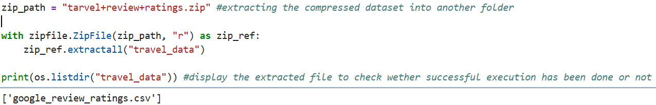

  - Data Preprocessing (Scrub Phase)
Before applying any techniques such as clustering or statistical analysis the dataset was inspected several times and prepared well to ensure that the variables are ready for further analysis. The preprocessing stage was mandatory to look for missing value, inconsistent data, unnamed or unexplained column and unnecessary row or column, problematic record to ensure that the Tourism Review Rating dataset contain appropriate data.

    - Initial Data Inspection
The initial step of the dataset was to inspect the dataset and identify the available variables. The column structure was thoroughly examined in order to maintain the integrity and foresee that the important data is not being deleted from the dataset. The dataset altogether contained user identifier, 24 different tourisms regarding activities which includes beaches, parks, museums and many more and an unnamed column 25.
While performing the below code which returns the column name, the unnamed column: 25 appeared.
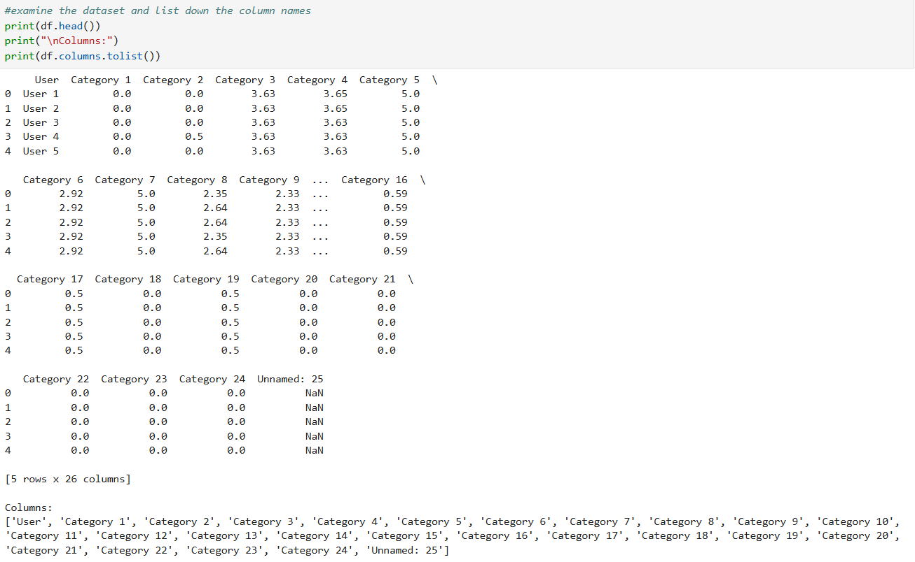
    - Identification of missing value and handling
Before proceeding to perform the analysis, there was a thorough check for the missing value. The detection of missing value is important in order to have clear statistical analysis and also it may have influence towards clustering process. The missing count value analysis was performed individually so we can get a proper count of missing values.
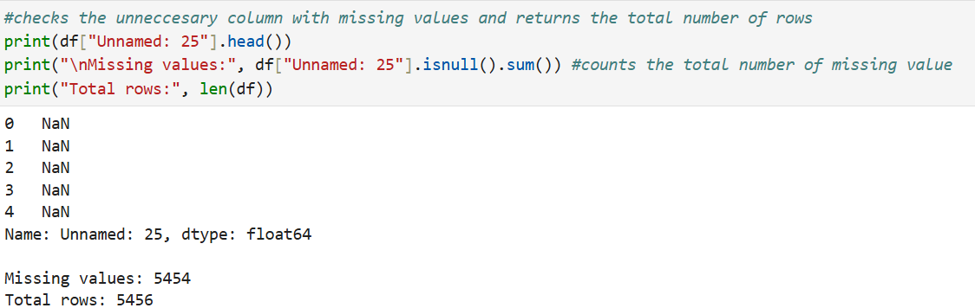
Here, at the above we performed a code where it returns the total number of row and also counts for missing value if any, but it identified in unnamed column there were 5,454 fields which appeared to be empty.
Later on, it was handled by dropping the unnamed: 25 column which contained 5,454 records which were NULL, which did not represent any tourism user ratings into them. The identified data-quality issue was rectified in the preprocessing stage. Following this changes, the data was re-checked in order to get missing value count to ensure they become suitable for EDA and clustering process.
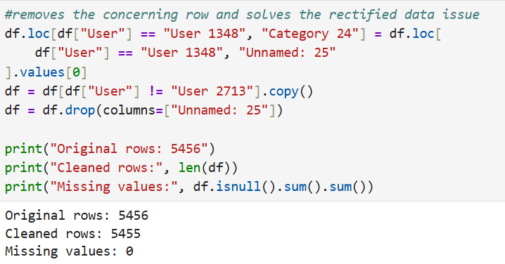
    - Investigation of inconsistent value and returning the data type
The dataset was then evaluated for inconsistent value in the tourism ratings format. During this process, one category local_services had a variable which was stored in string (str) instead of a numerical output. For performing the PCA and clustering it is important to change the string datatype to numerical / integer datatype because PCA and clustering are applied only on numerical values and not string, so it was to be rectified and corrected rather than ignoring, which could later on create an error in performing analysis and producing the accurate output.
The following code was performed to check for data type individually in each category
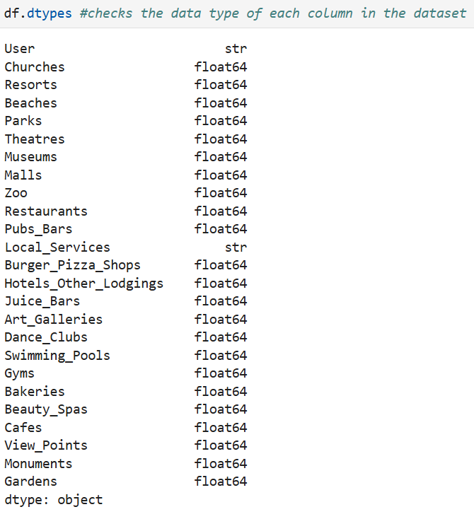
Here while detecting it can be seen that local service field has variable which is stored in string (str) datatype. The inconsistency needed to be addressed immediately because the multivariate analysis requires programs to be done on numerical inputs.
To resolve the identified error, the local_Service field’s data type was then converted to numerical datatype from string (str) datatype. This variable was then incorporated that it matches with other field’s numerical input and to ensure that there are no missing values.
Here’s the code for field’s conversion from string (str) datatype to numerical datatype
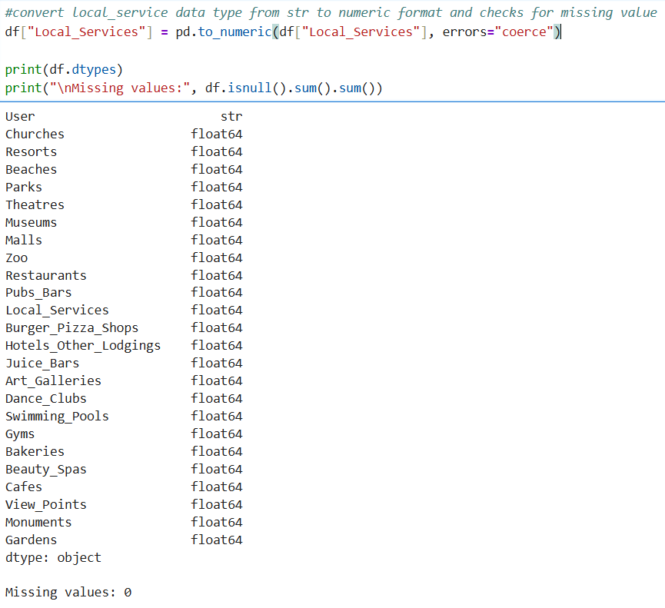
    - The final Validation
After the final data cleaning was done, the dataset was checked using the dimensions and the number of columns present in the dataset. The unnamed and empty class which was unnamed: 25 was discarded from the data frame. The final cleaned verdict of the dataset showed a total of 5,455 records and 24 different tourism categories and user identifier. For the modelling stage, the user identifier was also dropped because it was just an identifier rather than the tourism preference variable. This finally resulted in 5,455 user’s ratings which was recorded across 24 tourism activities which makes it a perfect matrix used for a multivariate data analysis.
Here’s the final validation code where the user identifier field has been dropped and final shape check has been done which returns the final number of rows and total number of user’s ratings after cleaning, which can be further used for analysis.
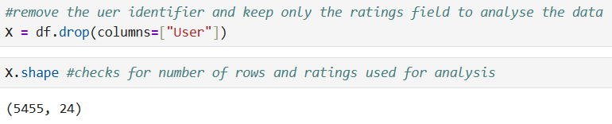
  - Exploratory Data Analysis (EDA)
Exploratory Data Analysis (EDA) is the process of examining the dataset, rectifying errors, summarising and visualising the dataset to gather the knowledge of its characteristics, identifying patterns and looking for relationships between variables and the data frame before performing any machine learning techniques.
In this following report, EDA was performed on the cleaned dataset of Travel Review Ratings to look for the patterns, where users provided ratings across 24 tourism categories. Statistics and graph visualisations were used to analyse the average rating values and present the same graphically. The findings from this stage were further used to support application and selection of PCA and clustering analysis in model phase.
The EDA was important because here because there are total of 5,455 users where they rated across 24 categories which could be difficult if went through each user individually. Also, this report aims to identify the distinct traveller segments based on tourism preferences, so EDA was used to analyse the patterns and look for variations before applying modelling or Machine Learning Technique.
    - Descriptive Statistics Analysis
The initial step involved statistical analysis of the ratings provided by users on tourism activities. This step provided with a clear numerical analysis and their average before proceeding to advanced stages.
Here is the final code where we found the mean, standard deviation, minimum, maximum and quartile
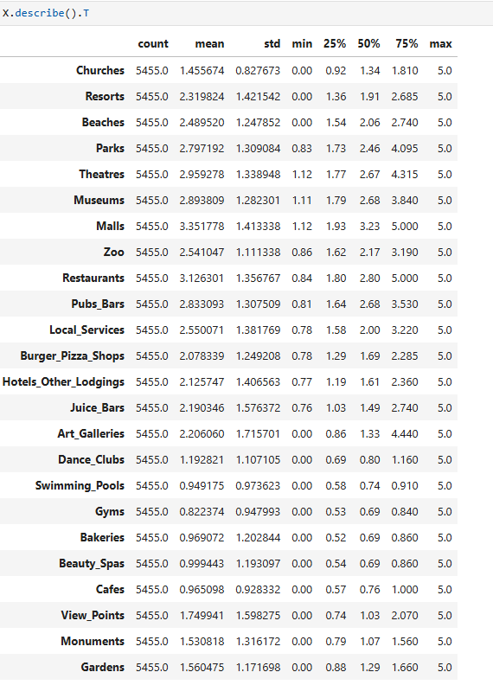
The following code x.describe.T gives us a directly summary by finding the mean, standard deviation, minimum, maximum and quartiles of the data provided. Here, the mean was used to find the average ratings in every category while the standard deviation measures of degree across variables. The minimum returns the lowest rating value from the dataset and maximum returns the highest rating value and quartile display information about the distribution of ratings.
The statistical analysis clearly shows how the variables can vary across the 24 different tourism categories provided. From the following analysis, it can be seen that differences in mean across categories shows that how some categories are relatively higher then compared with the other categories. The difference in standard deviation shows indicates that level of variation is not identical across 24 categories displayed.
It is important from a Data Science perspective in case of clustering because the variation across users and variables provides a basis for identifying groups based on their combined rating patterns. In contrast to that, the variation across users and variables provides a basis for identifying groups with similar rating patterns through clustering
From a real-world view, it can be seen that travellers cannot be kept in a homogeneous group as every user has different preferences.
    - Analysis of Average Ratings
Following the analysis, the average ratings of each category were analysed which could help place them in the order of highest to lowest category.
The following code represented the highest and the lowest rated category among the 24 categories which were initially sorted according to the highest ratings and then lowest ratings wise scale.
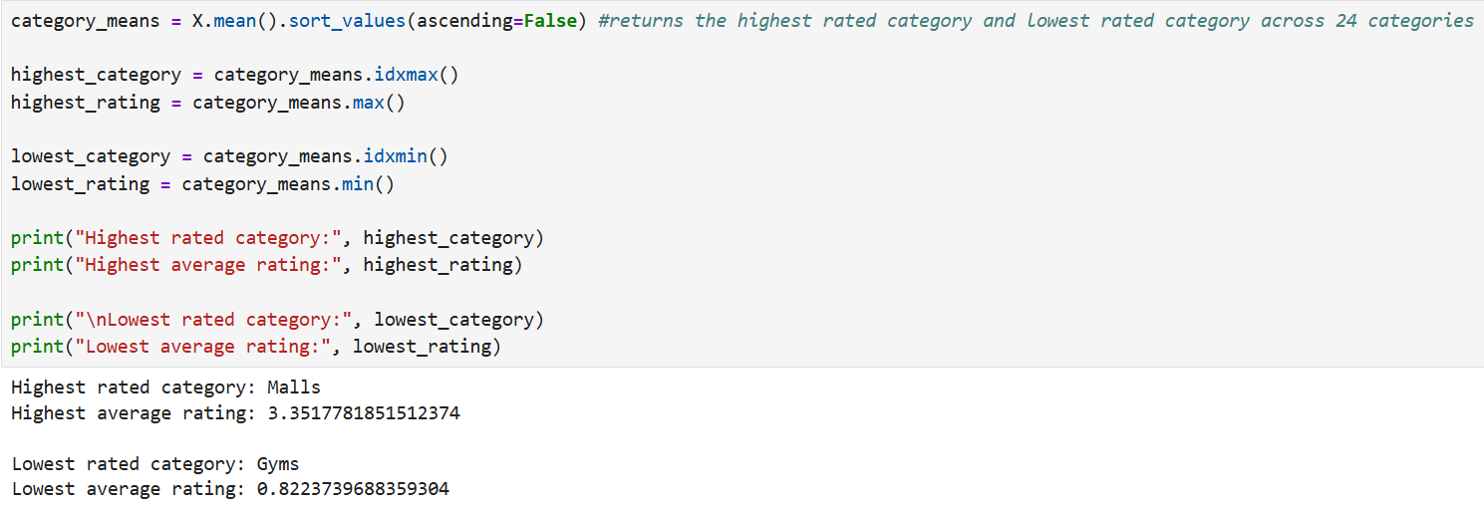
The analysis showed that the Malls was given the highest number of user ratings and the least preferred tourism activity rated by the users were Gyms.
However, the average ratings showed a mass behaviour because there are several categories which represented equal number of ratings. So, making decision based on which is highest rated and which is the least rated does not provide with accurate real-world recommendations.
The main aim of this report was not to find the category which is rated the highest and which is rated the least but by performing this analysis it can be used for further to see if the pattern follows a distinct travellers group profile.
    - Visualisation of Category-level preferences
After getting the output from the above code it was then visualised using graph. A bar chart was used to provide a clear comparison of user ratings provided, where the y-axis showed the average user ratings and the x-axis provided the 24 categories.
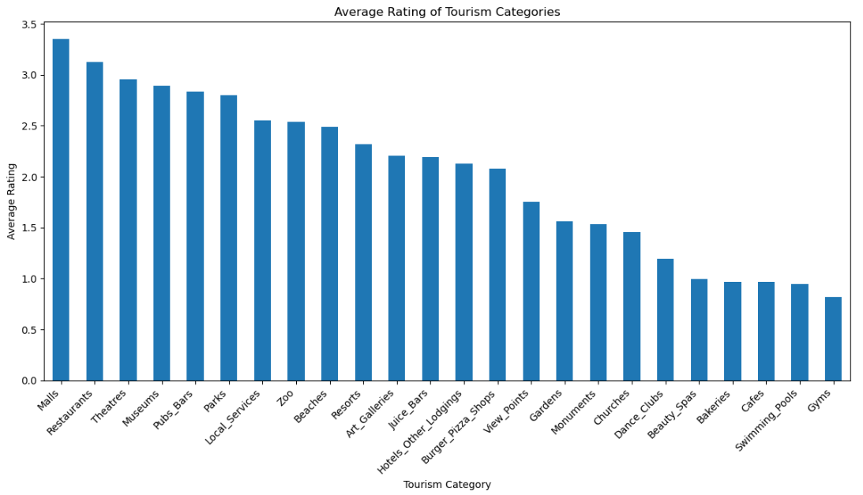
As seen from the graph, the ratings graph shows a varied average rating across the 24 categories. It can be examined that some categories showed a similar average ratings value while some category showed more noticeable difference. However, the visualisation represents the overall average behaviour of the users and does not group the travellers’ preferences.
The visualisation supports the main objective of the report by demonstrating that there is sufficient variation which gives away the pattern making it easier to group the travellers by their preferences.
    - Findings and Initial Observations
The exploratory Data Analysis (EDA) provided a good level of understanding of the behaviour of the ratings across the 24 categories. The comparison showed that the malls noted the highest average ratings while the gyms recorded the lowest average ratings. The statistics showed the pattern across the 24 categories, while the category-level identified some differences between the average ratings.
The bar chart further laid out a clear visualisation graph of how tourism activity ratings varied across them. Some were relatively higher while some followed a least average rating. This behaviour is just for the classification and knowledge of which is the highest rated and which is the least rated, this does not directly group them into travellers’ segments or build clusters.
Therefore, EDA provided a logical base for the next stages of the report. Since the dataset is a multivariate containing 5,455 users, 24 tourism activities and a user identifier. This provides the rationale for applying Principal Component Analysis (PCA) to understand the structure, then k-means clustering to identify and group them into similar traits and behaviours.
  - Modelling Techniques (Model Phase)
The model phase is use to apply the multivariate techniques to find a relationship between the user ratings across the 24 categories. PCA is used to reduce the dimensionality of the features keeping the important data untouched while k-means clustering creates individual clusters of the travellers’ who share same preferences and group them together.
    - Principal Component Analysis (PCA)
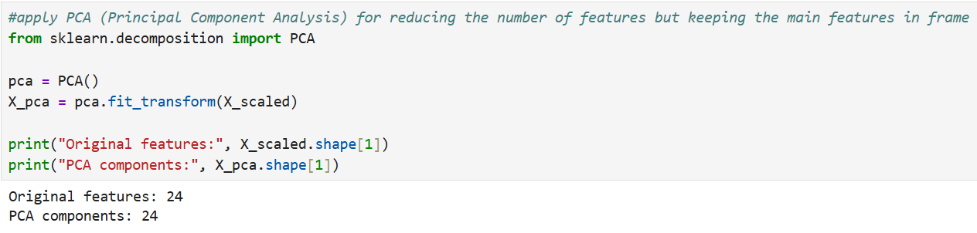
The Principal Component Analysis used the pca from sklearn.decomposition. The fit_transform() method first fits the PCA model to the standardised data by identifying principal directions that capture the greatest variation, and then transforms the observations into the resulting principal-component space. At this stage, all 24 components were retained to examine the complete variance structure before selecting a reduced number of components.
The final two statements uses .shape to check for number of featured columns after and before conversion.
Original Features : 24
PCA Components : 24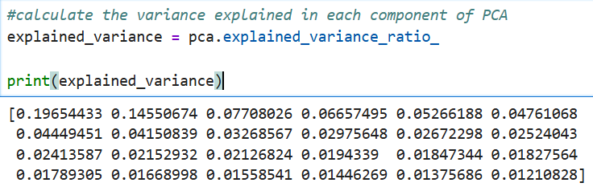
Both the cell displays 24 which confirms that PCA has not yet reduces the column feature. Instead, it establishes the complete transformation and generates principal component analysis required for explained variance analysis.
    - Explained Variance
The explained variance stage calculates how much information can be retained after performing the PCA which follows the dimensionality reduction.

This calculated the variance of each component. The explained_variance_ratio retrieves the proportion of the variation displayed by the principal components. Each value in array therefore represents the relative contribution of one individual component to the 24 categories.
The cumulative explained variance increases as additional principal components are included. PC17 remained below the 90% benchmark at approximately 89.12%, while PC18 exceeded the benchmark. The subsequent 18-component PCA model confirmed a cumulative explained variance of 90.95%. Therefore, retaining 18 components provides an evidence-based reduction from the original 24 dimensions while preserving more than 90% of the observed variance.
This reflects the dimensional nature across the 24 categories.
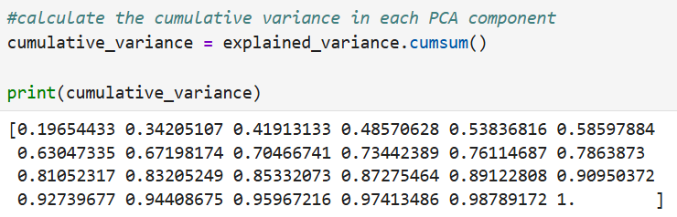
Here for calculating the cumulative variance cumsum() method was implemented. This methods adds the variance ratio of each component to determine the total variance when multiple components are combined together. Hence. The results of before code has a variations in output as compared with the recent because this calculation shows the combined variance up to the position.
The variance increases from 19.6% after PC1 to 34.2% in PC2 and continue increasing further to other PC’s. It can be concluded that by reaching PC18 almost it reached 90% which means that first 18 components retained to approximately 91% of the total variance.
This difference is important as it states that dimensionality-reduction function evaluates from the original dataset that it can be represented in fewer components. They are 18 new principal components representing combinations of the original 24 variables.
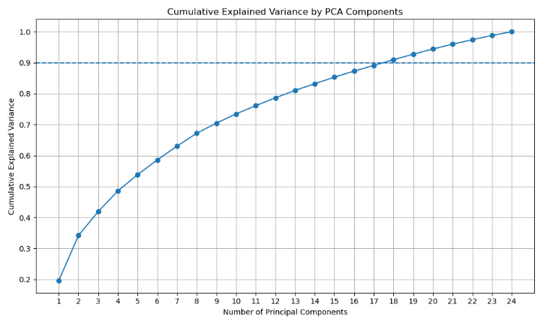
This graph lays out the relationship between the cumulative explained variance and the principal components after performing PCA. The dotted line represents the 0.9 which is 90% variance benchmark. The variance benchmark is referred as to which level the variance has retained.
The graph clears that the cumulative variance increases as the principal components are added. It also states that the first components shows a high variation while gradually the other components shows relatively less variation. PC17 remained below the 90% benchmark at approximately 89.12%, while PC18 exceeded the benchmark. The subsequent 18-component PCA model confirmed a cumulative explained variance of 90.95%.
In conclusion, 18 components are sufficient to retain more than 90% of the total variance in 24 categories. This provides a fair justification for selecting 18 components out from 24 categories.
The graph therefore proves that 18 components are sufficient out of 24 dimensional feature space, reducing 6 components with a cut off of 90% benchmark.
    - PCA transformation to 18 components
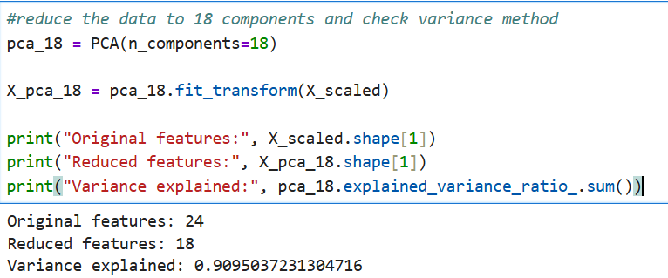
The 18 components was selected because at the PC18 it almost reached the 90% benchmark. This helped in reducing the 24 categories into 18 components. The PCA model was configures using the n_components = 18. The parameter limits the PCA components to first 18, while fit_transform() fits the PCA model to scaled data for analysis and presents the reduced data X_pca_18. The above output confirms that features were originally reduced to 18 from 24 and the variance explained ratio shows 0.9095 which is 90.95%. The code therefore successfully performed the dimensionality reduction on the analysis.
    - Two components PCA representation
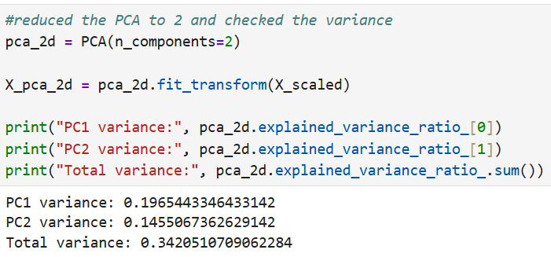
A separate PCA model was configured taking n_components = 2 to create a two dimensional representations of the scaled value. The fit_transform() fitted the PCA transformation and converted it into two separate PC1 and PC2 scores.
The output confirms that PC1 was 0.19 (19%) and PC2 is 0.1455 (14.55%) which altogether combines and creates 34.2 of the total variance. The two component reduction method was used to lay out a two dimensional representations of user rating, making it easier to plot and examine the observations.
    - K-means clustering and cluster number selection
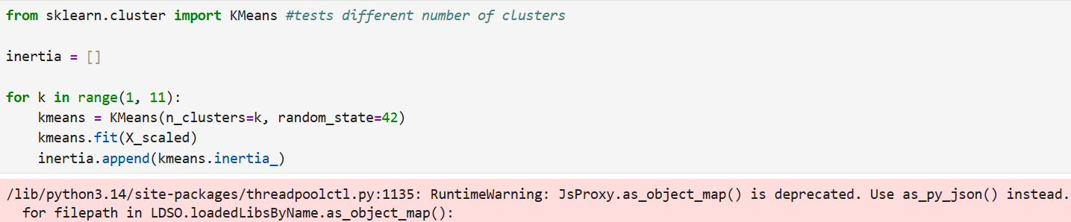
K-means clustering was applied to the dataset (X_scaled) for identifying different groups of users with similarity in tourist preferences. The elbow method was used by analysing the inertia across K = 1 – 10, while the silhouette score was used with K = 2 – 10 to provide an additional cluster quality score.
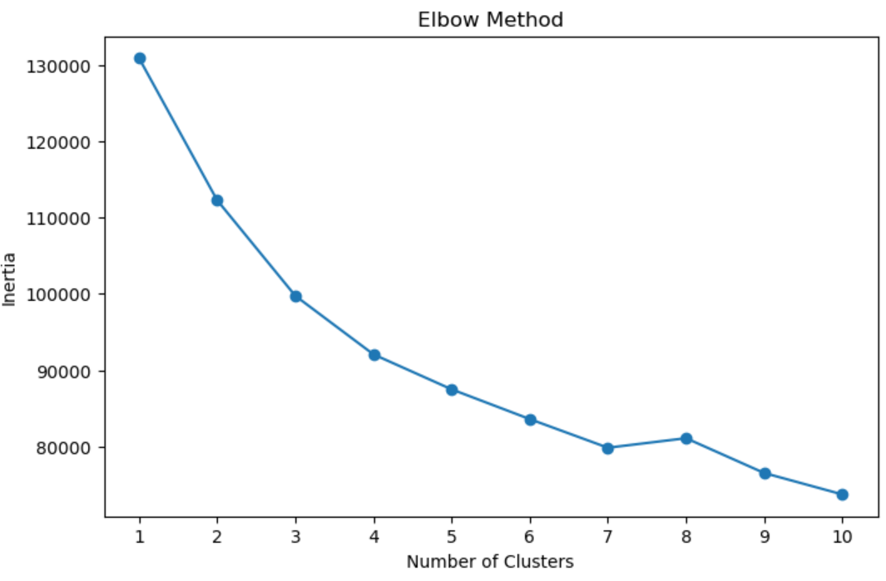
The elbow method shows that the increase in inertia is the diminishing number of clusters. The silhouette score analysis also provides complimentary proof by evaluating how well the observations can fit in the cluster as compared with neighbouring clusters. The cluster number selection was done on the basis of the cluster which had the highest silhouette score.
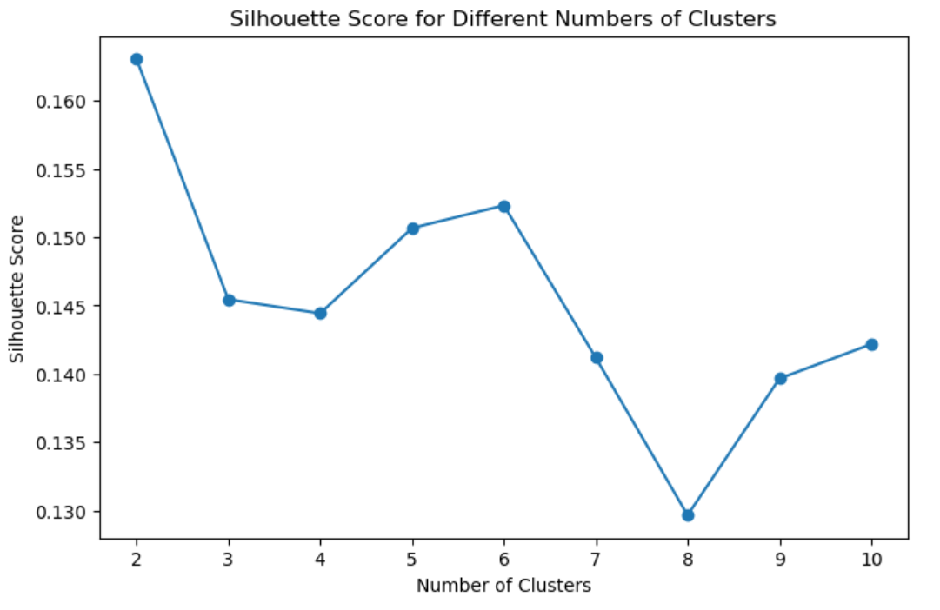
There was also analysis done on 10 clusters where it calculated the silhouette score, amongst which the cluster 2 was holding the highest silhouette score of 0.16303 and cluster 8 recorded the lowest silhouette score of 0.1296.
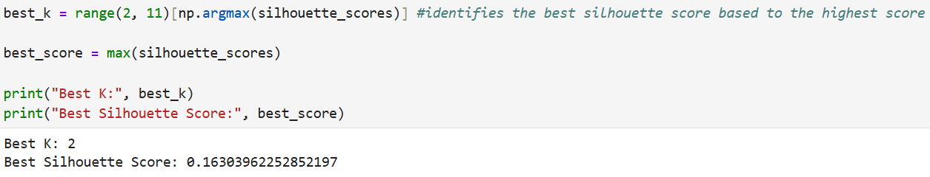
    - Final K-means model and segment labelling
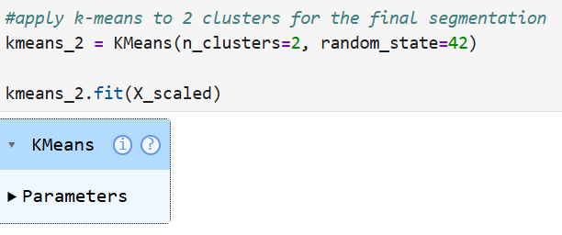
After analysing the silhouette score and cluster configuration through elbow method two clusters (Food, shopping and entertainment tourist and Nature and scenic tourist) were finalised for segmentation. The random_state = 42 was used to maintain the reproducibility of the clusters. N_clusters = 2 was the base for creating the k-model. In the very last version, n_clusters = 2 was used, producing two focal points that form the primary score patterns of the two clusters. Each individual was assigned to the group whose focal point most closely aligns with their average rating profile.

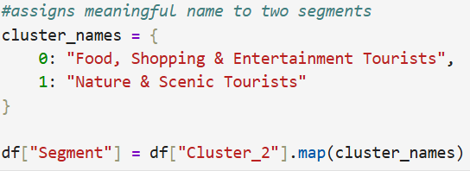

    - PCA Feature Contribution
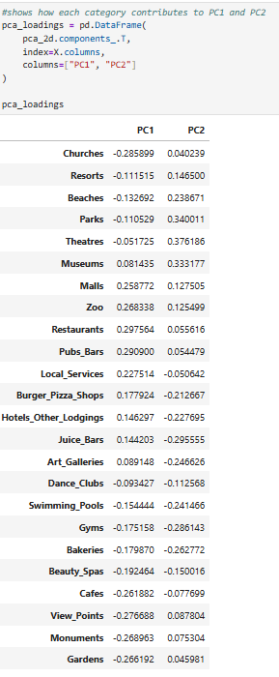
The PCA loading values were calculated in order to check that how 24 tourism categories contribute to PC1 and PCA2. The loading table shows the direction and strength of each category in respect to principal component. PCA loading values ​​were examined to determine the strength and path of the relationship between each of the 24 tourism categories and PC1 and PC2. Larger absolute weight values ​​indicate a more powerful contribution to the corresponding principal element, while the sign indicates the path of the connection.
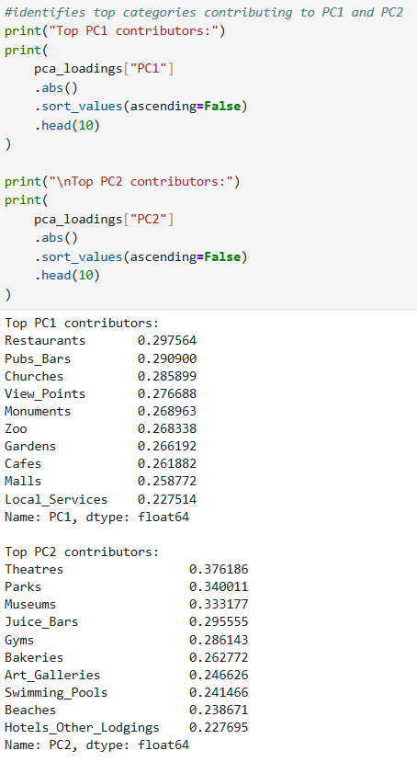
To make results look precise, both the PC’s categories were sorted from highest to lowest. This shows how different categories contribute differently in both PC’S according to their principal components. Therefore, PCA does not simply reduces the number of dimensions but also it identifies different tourism preferences that have greatest influence on major patterns.
    - Comparative Evaluation before and after PCA
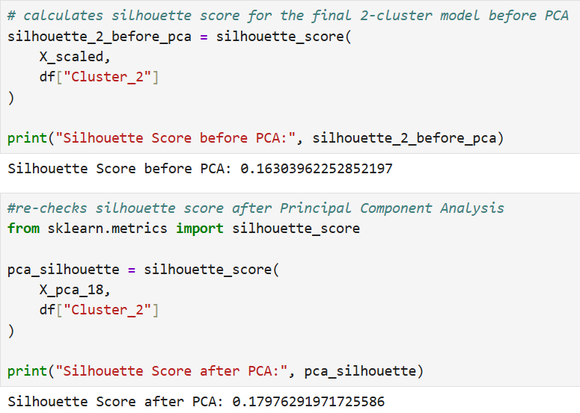
The calculation of silhouette score before and after PCA was done to check whether the final two segments remained effective after dimensionality reduction. Silhouette scores are compared before and after PCA to decide whether the very last two-group structure is maintained after dimensionality reduction. The rating improved from 0.1630 before the PCA to 0.1798 after the PCA, representing an absolute increase of approximately 0.0168. This indicates a small improvement in the separation and cohesion of the clusters after dimensionality reduction. The result shows that reducing the data to 18 components retained sufficient information for the final segmentation without negatively affecting the clustering structure.
  - Interpret
    - Result and Analysis
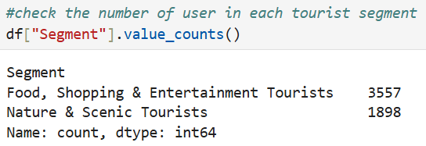
This code illustrates the distribution of users across two identified tourism segments. The Food, Shopping & Entertainment segment contained 3,557 users, while the Nature & Scenic segment contained 1,898 users. This indicates that the first segment represents the larger portion.
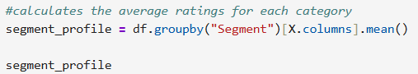
This segment profile compares how two traveller groups rate 24 different tourism categories, revealing the specific preference patterns that define each segment. While the Food, Shopping & Entertainment group Favors markets, restaurants, and leisure activities, the Nature & Scenic group shows a clear preference for outdoor spaces and natural landscapes. These distinct patterns show that travellers are driven by a combination of interests rather than just a single favourite activity. By capturing these multi-category behaviours, this profile provides a much deeper and more actionable understanding of traveller preferences than standard overall averages.
    - Model Evaluation
The final segmentation was evaluated using silhouette scores, with detailed before and after PCA evaluations. Our findings show that splitting things into two groups helps us spot a wide range of hidden patterns. However, the relatively modest Silhouette Scores indicate that the clusters are only moderately separated and that some overlap remains.
This means that certain users may also have rating styles that overlap between the two blocks. Therefore, instead of routine descriptions of individual travellers, group labels should be interpreted as strong preference styles. From a decision angle, the version is better suited as a tool for segmentation and planning than as an instrument for making specific predictions about individual customer behaviour.
    - Discussions
The overall findings demonstrate that the user preferences are not distributed uniformly across tourism categories. This is an important context for the tourism industry as it highlights how different preferences can be recommended differently rather than addressing a single market. Existing hospitality segmentations shows that customers preferences can vary which makes it useful for building accurate targets and marketing strategies.
From the above report, it is clear that analysis in the segmentation does not rely on individual preferences but from a multidimensional perspective. The PCA results further indicate that how several categories contribute to major dimensions of multivariate data. This suggests that the user’s have multidimensional interests which could be food, leisure or nature views rather than a single dominant type.
The Food, Shopping & Entertainment segment accounts for 65.2% of users, while the Nature & Scenic segment accounts for 34.8%, this does not show the imbalance of the categories. But it shows that the first category is highly prevalent in the dataset. A tourism operator could consider both the parts of the segments when allocating them with tourism packages.
From a managerial perspective, the results can be a different approach to customers engagement. This report not only provides which category is highly valued and which is the lowest but it also bundles how users interests are which helps in providing more accurate recommendations. At the same moment, the presented dataset can change depending on the destination, human psychology, food, leisure, circumstances and experiences. We cannot say that the presented report can stay uniform for several years.
    - Recommendations
1. Use the identified segments to provide more relevant attraction recommendations..
2. Develop tourism packages that reflect the preference patterns of each segment.
3. Consider stage size and characteristics when planning advertising and marketing campaigns and tourism offerings.
4. Include additional behavioural data, which include travel history, to strengthen future segmentation.
5. To develop promotional techniques that reflect the exclusive priority framework of the two segments.
    - Summary
The Interpret phase translated the technical findings into practical tourism and hospitality insights. The results demonstrate how preference-based segmentation can support more focused marketing, personalised recommendations and tourism planning while recognising the limitations of rating-based customer profiles.
- Conclusion
This project addresses the challenge of identifying distinct traveler segments by analyzing user ratings across 24 unique tourism categories. Following a structured data science workflow—comprising data cleaning, standardization, Exploratory Data Analysis (EDA), Principal Component Analysis (PCA), and K-Means clustering—the analysis successfully uncovered two primary traveller profiles: Food, Shopping & Entertainment Tourists and Nature & Scenic Tourists.
The results demonstrate that evaluating tourism ratings collectively uncovers macro-level preferences that are invisible when analysing individual categories in isolation. Applying PCA allowed us to compress the dataset and eliminate noise while retaining the core variance of the data. Subsequently, K-Means clustering established a clear, interpretable framework for grouping users with shared rating behaviours.
From a strategic hospitality and tourism perspective, these data-driven profiles provide actionable insights for designing targeted marketing campaigns, building personalized recommendation systems, and curating specialized travel packages. However, these clusters should be interpreted as fluid preference trends rather than rigid consumer identities, as the underlying dataset lacks the demographic or behavioural metadata required for absolute profiling. Ultimately, this project highlights how Python-based multivariate analysis can bridge the gap between raw customer data and customer-centric business strategy.
- References
Carvache-Franco, M., Regalado-Pezúa, O., Sirkis, G., Carvache-Franco, O. and Carvache-Franco, W. (2023) ‘Market segmentation in urban tourism: A study in Latin America’, PLOS ONE, 18(5), e0285138. Doi: 10.1371/journal.pone.0285138.
D'Urso, P., De Giovanni, L., Disegna, M., Massari, R. and Vitale, V. (2021) ‘A tourist segmentation based on motivation, satisfaction and prior knowledge with a socio-economic profiling: A clustering approach with mixed information’, Social Indicators Research, 154, pp. 335–360. Doi: 10.1007/s11205-020-02537-y.
Hernández, J.M., Bulchand-Gidumal, J. and Suárez-Vega, R. (2021) ‘Using accommodation price determinants to segment tourist areas’, Journal of Destination Marketing & Management, 21, 100622. Doi: 10.1016/j.jdmm.2021.100622.
Pooja, K., Upadhyaya, P. and Mohanty, A. (2025) ‘Segmenting Indian domestic tourists: Preference-based latent profile analysis’, Humanities and Social Sciences Communications, 12, 1839. Doi: 10.1057/s41599-025-06124-9.
Rishi, B. and Chatterjee, T.K. (2023) ‘Typology of Indian domestic tourists: Clustering based on motives to visit’, FIIB Business Review. Doi: 10.1177/23197145231151328.
Schrader, J., Pinedo, L., Vargas, F., Martell, K., Seijas-Díaz, J., Rengifo-Amasifen, R., Cueto-Orbe, R. and Torres-Silva, C. (2025) ‘Application of artificial intelligence techniques for the profiling of visitors to tourist destinations’, Frontiers in Artificial Intelligence, 8, 1632415. Doi: 10.3389/frai.2025.1632415.
Smith, M.K., Pinke-Sziva, I. and Berezvai, Z. (2023) ‘The relative importance of culture in urban tourism: Implications for segmentation’, Consumer Behaviour in Tourism and Hospitality, 18(2), pp. 157–173. Doi: 10.1108/CBTH-01-2022-0026.
Wang, L., Wang, S., Yuan, Z. and Peng, L. (2021) ‘Analysing potential tourist behaviour using PCA and modified affinity propagation clustering based on Baidu index: Taking Beijing city as an example’, Data Science and Management, 2(4). Doi: 10.1016/j.dsm.2021.05.001.
Airlangga, G. (2025) ‘A Comparative Analysis of Clustering Algorithms for Expedia’s Travel Dataset’, Sinkron: Jurnal dan Penelitian Teknik Informatika, 9(1), pp. 476–483. doi:10.33395/sinkron.v9i1.14343.
**DOI : Digital Object Identifier : It’s a specific number given to the papers.

